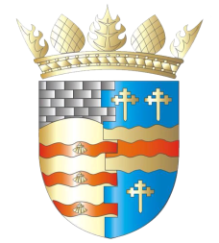**BLAIRGOWRIE AND RATTRAY COMMUNITY COUNCIL**

**Ordinary Meeting – Draft Agenda**

**Thursday, 11th September 2025, at 7pm**

**at the BaRI Building, High Street, Blairgowrie,**

**and online via Zoom**

1. Welcome and Introductions

2. Apologies

3. Adoption of draft minutes of 14th August 2025 meeting  
4. Police & Fire Reports

a) Riverside safety

5. Representation of Young People

6. Matters raised by members of the public

7. Regular reports

a) Resilience/Flooding/First Responders PR/SM

b) Climate Action DC/GP/JM

c) Twinning GP/SM/DC/AS

d) Maintenance in Blairgowrie & Rattray

i. Built Environment

a) Electrical Connections at Wellmeadow (B&R Common Good Fund?)

ii. Open Spaces

e) Citizen/Young Person/Group of the Year

8. Matters Arising/Reports Back

a) Emma Street laundry

b) Football Pitch

c) Gallowbank Footpath

d)Top up tap

e) Remembrance Day wreath

f) Highland Games

g) Community Council Elections

9. Traffic Matters

a) Speeding Meeting

10. Planning Matters

11. Chair’s Report

12. Treasurer’s Report

13. Councillors’ Reports

14. AOCB

Please note: With the permission of all attendees, the minute taker will record this meeting solely for the purpose of writing up the minutes, will not share the recording, and will delete the recording as soon as the minutes have been written. The Chair will ask for permission at the start of the meeting.

Awaiting info: CCTV, Community Action Plan, Local Place Plan

**Next meeting: AGM & Ordinary Meeting, Thursday, 9 October 2025, 7.00pm**